PATRICIO JOSÉ MILLET GARRIDO
ST 43 No. 349 POR 26 A Y 28, FRAC. MONTE ALBAN, MERIDA, YUCATAN, MEXICO, C.P. 97114 CEL +52 (999) 262 4245 • E-MAIL patomgczm@hotmail.com

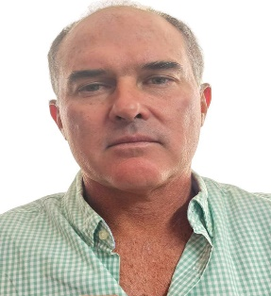

PROFILE Entrepreneur dedicated to real estate activity in the Yucatan peninsula for more than 25 years. I carry out purchase or rental operations of property and land for commercial or private use.
EDUCATION Titration
Law Degree, Marist University of Merida
Graduated in 1996
EXPERIENCE REAL ESTATE ADVISOR
For more than 25 years I have worked as an independent professional in the real estate field. My main activities are the purchase and sale of properties, real estate and land.

