CONFIDENTIAL INFORMATION

2025
Personal Financial Report

Client Name

Neil Emberson
(Our meeting on 03/01/2025.)
Adviser's Report:

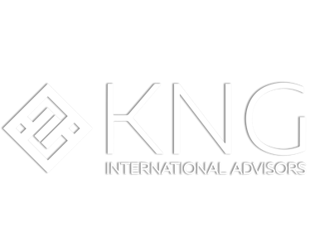
Personal Financial Report

2025

Introduction

This is your wealth plan for investing a capital sum of €150,000 in a diversified portfolio of international investment instruments. All portfolio assets are available through a single international investment platform regulated by the FSA of the Isle of Man, UK. Below are suggested investment asset allocations that we have researched and used for several years. Each has certain liquidity terms and conditions and its own investment horizon, but all would be liquid within 5 years. The portfolio can be modified according to your objective, the amount of the investment and your current attitude to risk. It has been designed to be simple and easy to understand. At our next meeting, we will look at the investment instruments in detail to give you a better idea of the potential future returns on the investment and carry out a risk assessment to identify your profile.

We recommend locating your platform in a highly regulated jurisdiction with the highest level of investor protection and confidentiality. In this case, we recommend the United Kingdom (Isle of Man for non-UK residents), where 100% of your investment is managed in segregated accounts held in custody by law. This means that client capital is fully protected in the unlikely event that the bank or financial institution goes bankrupt. Financial institutions are regulated by the Isle of Man FSA, and clients have the added benefit of professional indemnity insurance that banks are required to have. There are three additional layers of investor capital protection in the Isle of Man:
- Depositor compensation scheme
- Compensation plan for the Authorized Collective Investment Scheme (Isle of Man Government - Home)
- Financial Services Compensation Scheme (FSCS) of the United Kingdom | FSCS)
As a non-resident, all taxes on growth and interest payments on your investment portfolio will be deferred until you withdraw your profits and receive them in your country of residence. There will be no tax withholding in the UK.

An additional service we offer is the opening of an Isle of Man (UK) international debit account to receive withdrawals from your investment account in USD/EUR/GBP. This service includes:
- International debit card (VISA)
- Online banking (view accounts and make transfers, etc.)
- Mobile application
We recommend that you review your tax situation with a tax advisor to ascertain your tax status and obligations in your country of residence.

Kind regards,
KNG International Advisors | Personal Financial Report for [Client Name] — Dec 2025 (Confidential) Page 2
Advisor's Name
International Financial Advisor
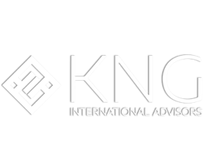
Grupo Capital International
http://www.capital-iom.com/
Recommendations
Capital International Group is a UK-licensed bank (licence number 1.2) based and operating from the Isle of Man. (Online Services - Company Overview (gov.im). They specialise in providing financial services, including trading and brokerage, custody and administration, and investment portfolio management. Their credit rating is AA from S&P. It was established in 1996, when Capital International Group was founded to provide custody, nominee and brokerage services on the Isle of Man. Since then, an integrated suite of financial services has been developed, and Capital International Group now has approximately $5 billion in assets under management. The Isle of Man FSA regulates Capital International Limited (iomfsa.im)

The Group's stockbroking business is a member of the London Stock Exchange and offers clients the ability to purchase securities listed on any regulated investment market. Assets are held in custody by Pershing Limited, part of The Bank of New York Mellon Corporation (BNY). BNY has more than £42 trillion in assets under custody.

Features of Capital International Group's open architecture international investment platform - Trade Ex
This investment account has the infrastructure, respective custodians, and partnerships with brokers necessary to buy, sell, hold, view, and manage all types of investments. For example: shares, bonds, funds, ETFs, etc.
- Easy to manage multiple investments on a single platform
- Low minimum investment at a very affordable level for specific investments
- Interest, dividends and profits can be accumulated and reinvested tax-free.
- High level of protection for investors through segregated accounts and having all assets in custody
- Secure jurisdictions (protection against geopolitical issues in Latin America)
- Multi-currency (Euro, USD, GBP, etc.)
- Can have multiple account holders due to wealth succession issues
Tradex administration fees (CIG0 to CIG5) – choose which structure suits YOUR CUSTOMER
KNG International Advisors | Personal Financial Report for [Client Name] — Dec 2025 (Confidential) Page 3
Administrative expenses - Minimum investment £50,000 USD/GBP/EUR | CIG0 | CIG3 | CIG5
Set-up/custodian fee  This is a percentage of the capital invested that is segregated into a reimbursement credit sub-account. The annual fee is deducted from this amount. | 0.125% per year until the ROI is zero (approximately 4 years).  0.5% of the investment value is segregated into the refund credit account. | 0.7% anual hasta que el RC sea cero (5 años aprox.)  El 4,5% del valor de la inversión se segrega a la cuenta de crédito de reembolso. | 1.1% anual hasta que el RC sea cero (5 años aprox.)  El 6,5% del valor de la inversión se segrega a la cuenta de crédito de reembolso.
Annual custody fee | 0.26% per year (min 220 GBP) | 0.26% per year (min 220 GBP) | 0.26% per year (min 220 GBP)
Annual management commission | 1.5% | 1,5% | 1,5%
Migrating assets from another investment account | £35 | £35 | £35
Purchase/sale rate | 0.25% (max. $180 USD)* | 0.25% (max. $180 USD)* | 0.25% (max. $180 USD)*
Recommendations
We have 3 regulated DFM options - Talk to the KNG team to determine which one to recommend.

Growth investment account with a discretionary fund manager.

Administrative fees
Minimum investment £100,000 USD/GBP/EUR
Establishment/custodian fee | 0%
Annual custody fee | 0.4% per year (min 220 GBP)
Annual management commission | 1.95%
Migrating assets from another investment account | £35
Purchase/sale rate | 0.25% (max. $180 USD)*
*Depending on the investment amount this cost decreases

High-Yield Fixed Income – Direct Investment
This portfolio will be managed on a non-discretionary basis. This means that we will recommend investment instruments that generate a fixed income of between 7% and 12%, and you will be required to sign the trading sheet to authorise each transaction in advance. Our team of professionals carries out a strict selection process and thorough due diligence on each investment instrument, which is available upon request. This is an ongoing process, and updates are also available upon request and through our portal. All fixed income instruments are senior secured debt instruments that may be corporate bonds or loan notes. These instruments are asset-backed through the use of a security trustee regulated by the FCA under UK or European law that has a first charge on all assets of the operating company, or the instrument is insured by an A-rated insurance company.

Equities - Stock market (Global)
This daily liquid equity UCITS fund portfolio is aimed at capital growth over a period of more than 5 years. They will invest in individual equities, ETFs, investment grade bonds and commodities. All assets are daily liquid, although there may be an exit fee within the first 5 years, so please refer to the liquidity section in the details below. We research several asset managers and compare the intricate details of their strategies, the performance of the base and how they compare to their respective indices in the medium and long term. The allocation of these funds and the subsequent selection are in line with your risk profile after completing a risk questionnaire for investors.

Alternative Investment and Private Equity Asset Allocation
We will also invest in alternative investments that are uncorrelated with global stock markets, such as REITs, digital assets and other alternative strategies. Finally, we may invest a smaller allocation in private equity to generate ‘alpha’ in the portfolio for the medium to long term. Due to the nature of these investments, there will be restrictions on the liquidity of the capital, depending on maturity dates or estimates for implementing exit strategies in the case of private equities. These restrictions will be explained in detail prior to investment.

KNG International Advisors | Personal Financial Report for [Client Name] — Dec 2025 (Confidential) Page 4
Recommendations

Managed Portfolios for Discerning Investors
Every client is unique, and financial needs vary according to each individual's objectives and risk profile. That is why we offer personalised investment solutions through our managed portfolios, designed to maximise returns while remaining aligned with our clients' objectives and risk tolerance.

Personalised Management and Diversified Investment Strategies
Our approach focuses on active and strategic management, based on a thorough analysis of global markets and constant evaluation of investment opportunities. Backed by a team of investment experts, our portfolios are designed to suit a range of risk profiles, from conservative to aggressive, ensuring that each client receives a strategy tailored to their financial situation and long-term goals.

Customer Profiling and Tailored Management
Each client is carefully profiled to identify their risk tolerance, investment horizon and specific objectives. Based on this assessment, our managers design a diversified portfolio that not only maximises opportunities for returns, but also protects against market volatility. This approach ensures that our clients are always on track to achieve their financial goals without compromising their security.

KNG International Advisors | Personal Financial Report for [Client Name] — Dec 2025 (Confidential) Page 5
Recommendations

Requirements for applying for the platform and suggested portfolio
- Copy of your ID (passport or national identity card)
- Take a clear selfie with your ID without covering your face and ensure that the document is legible.
- Proof of address with your name on it, dated within the last 3 months (telephone, electricity or water bill, bank statement).
- Take a clear selfie with your proof of address without covering your face and ensure that the document is legible.
- Bank account details and a recent statement of the source of funds.
- Details of the bank account where you would like to receive future withdrawals: these can be updated in the future, but must be in the name of the same account holder.
- Tax identification number (TIN)
- 6/8 references from friends or colleagues who would be interested in our services.

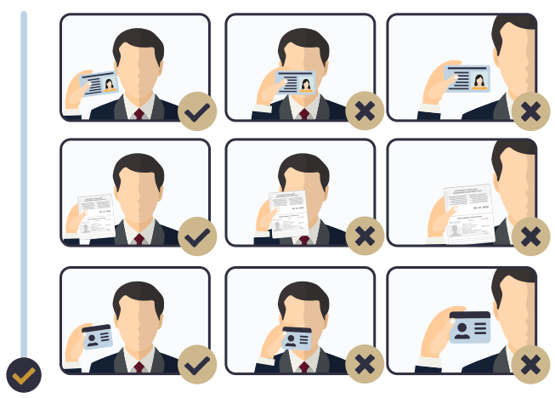

KNG International Advisors | Personal Financial Report for [Client Name] — Dec 2025 (Confidential) Page 6



Work with Us
www.kngadvisors.com
Website
email@kngadvisors.com
Email Address
+52
Phone Number

