Resume
Contact Details
Name: | Ms Anowa Namukolo Changa
Date of Birth | 13th February 1981
Address: | Farm 916A  lilayi Lusaka  Zambia
Phone: | +260 0969 635337
Mobile | +260 0950003702
Email Address: | anowaau@hotmail.com

Career Objectives
Summary: | I am a qualified Business Development Executive with extensive experience in this field seeking to further my career by acquiring a challenging role in a growth oriented firm.
Education/Qualifications
Institution: | St. George Institute of Professionals
City/Country: | Melbourne/Australia
Qualifications: | DIPLOMA OF MULTI-MEDIA & GRAPHIC DESIGN
Completed: | 2005

Institution: St. George Institute of Professionals
City/Country: | Melbourne/Australia
Qualifications: | ADVANCED DIPLOMA IN BUSINESS Marketing
Completed: | 2002

Institution: | Latrobe University
City/Country: | Melbourne/Australia
Qualifications: | BACHELOR OF BUSINESS( Marketing & Financial Mgt)
Completed: | 2004

Institution: | Edith Cowan University
City/Country: | AIBT Lusaka/ Zambia
Qualifications: | MBA ( International Business)
Completed: | Currently Pursuing

Employment History
ZAMTEL

Start Date: | Mar 2018
End Date: | Current
Position/Title: | Mobile Sales Officer – LTE Unit
Responsibilities:  OCEAN BASKET | - Lead Generation, Sales Presentation, Customer Relations Management.
Start Date: Sept 2016
End Date: FEB 2018
Position/Title: COMMERCIAL MANAGER
Responsibilities:
- managing day to day of office duties
- scheduling appointments and meetings
- maintaining files and records
- planning and conducting research
- providing quality customer service
- marketing and advertising with emphasis on increasing sales
- ensuring that staff comply to the standards of the institution
- Analyzing data and providing recommendations for decision making
- providing a conducive working environment
- implementation of the directors decisions

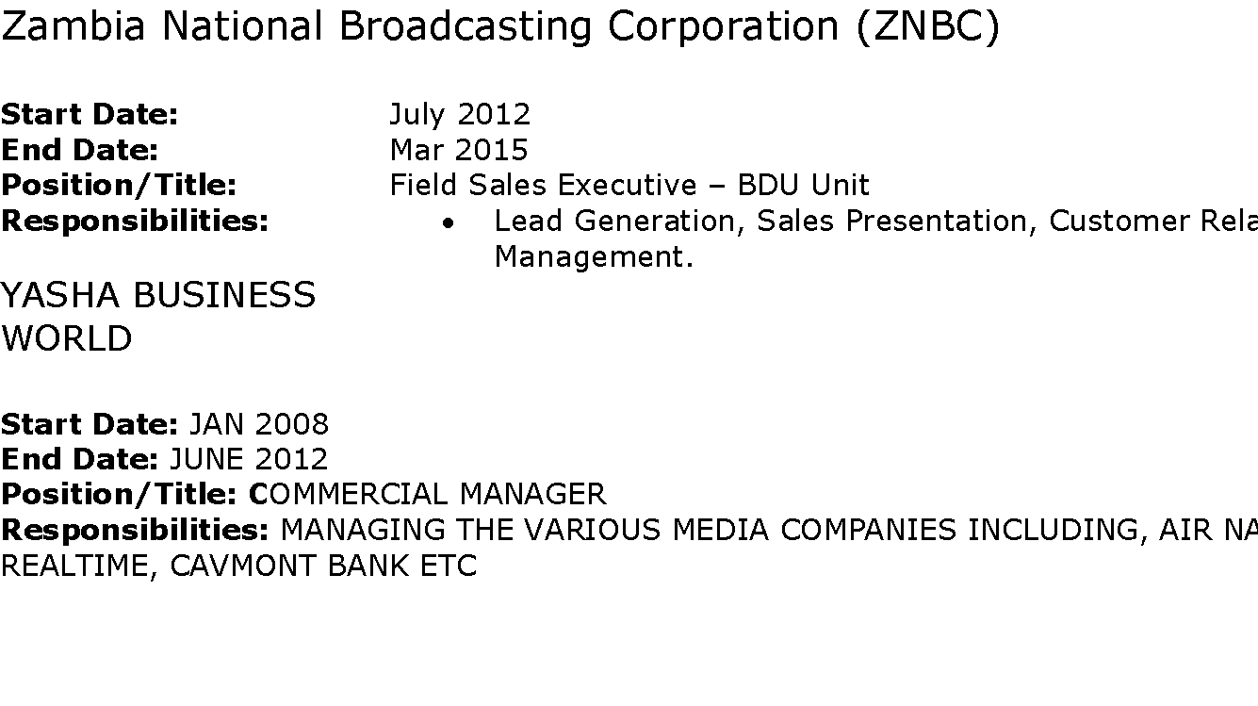
TAJ PAMODZI HOTEL
Start Date: | Nov 2006
End Date: | Oct 2007
Position/Title: | Banquet Sales Executive
Responsibilities | - Maintain Database of current and aspiring customers.  - Marketing and Sales Presentations to prospecting clients etc.  - Formulate advertising themes for special events.  - Coordinate the banquet and sales departments in line with our marketing strategy.

STELLAR CALL CENTRE
Start Date: | Apr 2005
End Date: | Jun 2006
Position/Title: | Sales Representative
Responsibilities:  Achievements: | Outbound/Inbound calling and attending and responding to customer enquiries as well as ascertaining the best possible resolution to their problem or need (objection handling).  Received the award of best Telesales agent for 2006
Emily Lenny
Start Date: | Dec 2000
End Date: | Aug 2005
Position/Title: | Receptionist
Responsibilities:  Achievements: | - Attended to client queries and questions over the phone as well as face to face.  - Handled customer complaints.  - Managed all other administrative duties.  Staff of the Month for December 2002
Skill Summary
Non Technical Skills: | In my previous positions I have demonstrated high level work ethic, including good communication and leadership skills.
Computer Skills: | MS Excel; Advanced  ACCESS; Advanced
Other: | Food & Hygiene certificate

Professional Memberships
I am a graduate member of the Zambia Institute of marketing

Awards
- Certificate of attendance for selling and sales Management Workshop (ZIM)
- Statement of attainment for occupational hygiene (Food Sense Australia)

Interests
Sport, Travel, Backpacking and Challenges.

References
Mwanza Kapako
Phone: | +260 977778577
Organisation:  Position: | P.O.BOX 35165 Lusaka  Consultant Head of Finance

Mr. Kshitij Dewan
Phone: | +260 211 255376
Organisation:  Position: | Shreeji Investments LTD  Executive Director

Mr. Frank Kalizinje
Phone: | +260 977884883
Organisation:  Position: | Kaingo Leisure Ltd  E/ Director

